JAVA Collections
What are Collections?
- The Collections Framework is a sophisticated architecture for storing and manipulating groups of objects.
- Think of it as a standardized "toolbox" that provides developers with ready-made data structures (like lists, sets, and maps) and algorithms (like sorting and searching) so you don't have to write them from scratch.
Core Components:
- Collection: A collection represents a group of objects, known as its elements. The JDK provides implementations of more specific sub-interfaces like Set and List.
- List: A list is an ordered list of objects, where the same object may well appear more than once. For example: [1, 7, 1, 3, 1, 1, 1, 5]. It makes sense to talk about the "third element" in a list. You can add an element anywhere in the list, change an element anywhere in the list, or remove an element from any position in the list.
- Queue: A queue is also ordered, but you'll only ever touch elements at one end. All elements get inserted at the "end" and removed from the "beginning" (or head) of the queue. You can find out how many elements are in the queue, but you can't find out what, say, the "third" element is. You'll see it when you get there.
- Set: A set is not ordered and cannot contain duplicates. Any given object either is or isn't in the set. {7, 5, 3, 1} is the exact same set as {1, 7, 3, 5}. You again can't ask for the "third" element or even the "first" element, since they are not in any specific order. You can add or remove elements, and you can find out if a certain element exists.
- Map: An object that maps keys to values. A map is not ordered and cannot contain duplicate keys (but can contain duplicate values). Each key can map to at most one value.
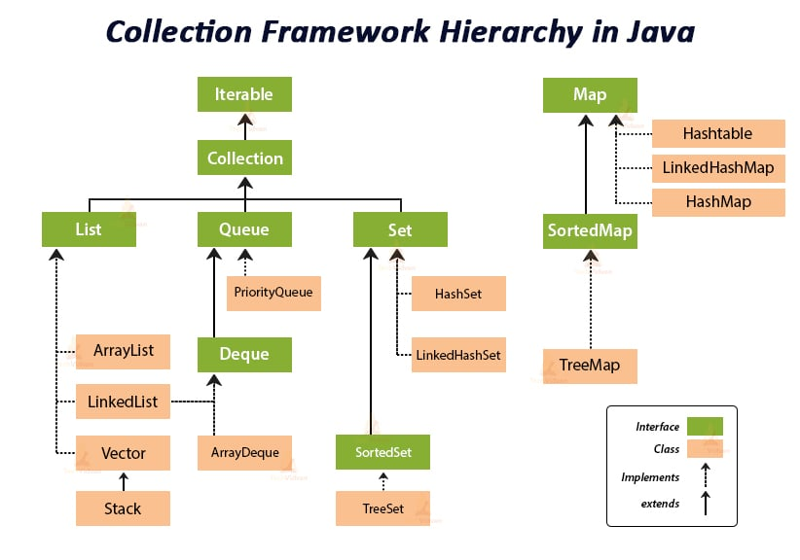

- Iterators – Navigators:
Iterators provide a standard way to cycle through a collection without knowing how that collection is structured (e.g., whether it's an array or a linked list).

- Comparators – Rulers:
- Utility Class:
- Specialized Collections:

